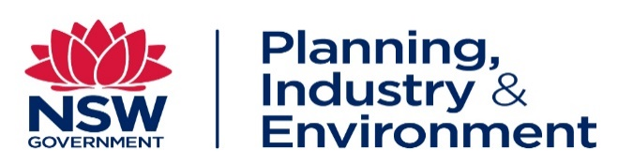

Application Guide

Helpful Tips

- Click ‘Apply Online’ at the bottom of the job advertisement

- Complete all the questions in the online application.

- In the section titled Supporting Documents, please attach:
  - Cover Letter (maximum of 1 page)
  - Resume (maximum of 4 pages)

- If you’d like an overseas qualification to be considered as part of your claim for a role, you must identify the Australian qualification of which it is an equivalent and the Australian industry or government body which recognised your qualification

- Be careful when unticking any files from your profile that you have already marked as relevant to your application. Unticking a file will remove the attachment from your application and this could result in your application being incomplete

- Ensure your JobsNSW profile is updated with your current contact information and referees. You are required to provide e-mail addresses for two nominated referees, one of which should be a current or recent supervisor

- All applicants to ongoing roles MUST be Australian or New Zealand citizens or have permanent Australian residency status at the time of application. Applicants for temporary roles MUST either meet the above mentioned requirement or have a visa allowing them to work in Australia for the full duration of the temporary role.

- Please do not attach proof of identification, qualifications or other documents. These documents will be sighted at interview if you progress to this stage of the process

- All applications must be submitted online by the advertised closing date.

- You may be required to complete online assessments, skills testing or work samples as part of the assessment process

- Technical enquiries: If you receive error messages during the application process, need a password reset or general assistance to create a profile and submit an application contact I Work for NSW support team on 1800 562 679 (Mon-Fri) or email support@jobs.nsw.gov.au for assistance.

- The Planning Industry and Environment Cluster welcomes applications from people with disability. Please indicate if you have any accessibility requirements in your application or speak with the contact person if preferred. We provide reasonable adjustment for people with disability during the recruitment process and welcome a conversation about your requirements

- The Planning Industry and Environment Cluster is committed to offering flexible work arrangements where possible. We encourage candidates to discuss options available for this role with the Hiring Manager.

