GUIDE TO APPLYING FOR RMS ROLES VIA IWORKFORNSW
Step 1: To view roles with RMS go to www.iworkfor.nsw.gov.au. You can search by job category, location, agency or organisation via the relevant drop down menus. Alternatively, you can type the job name or job reference number in the enter keywords or job reference/ID field as shown below.
Step 2: click on the job title to view the ad.
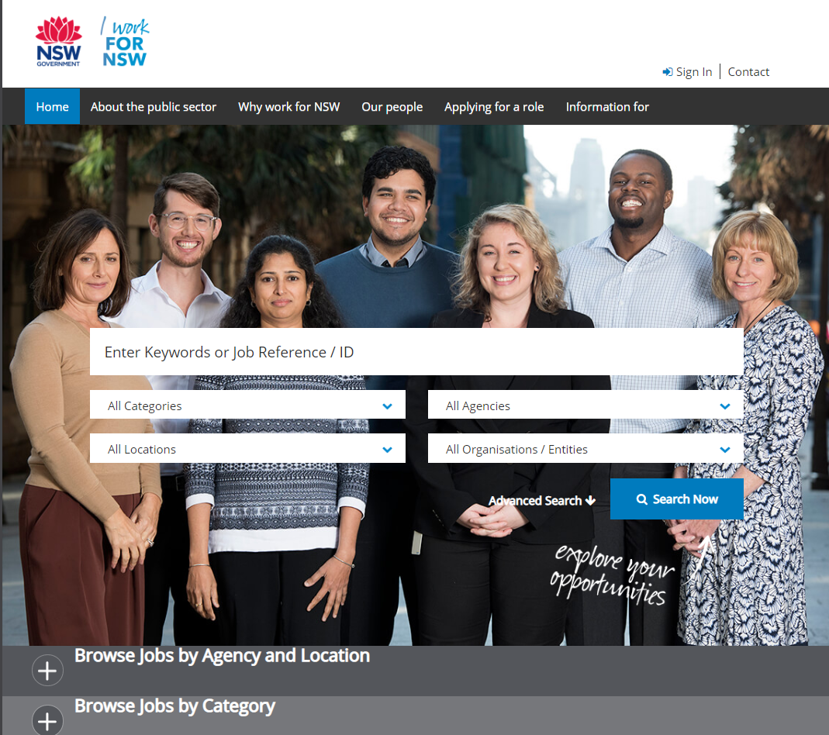
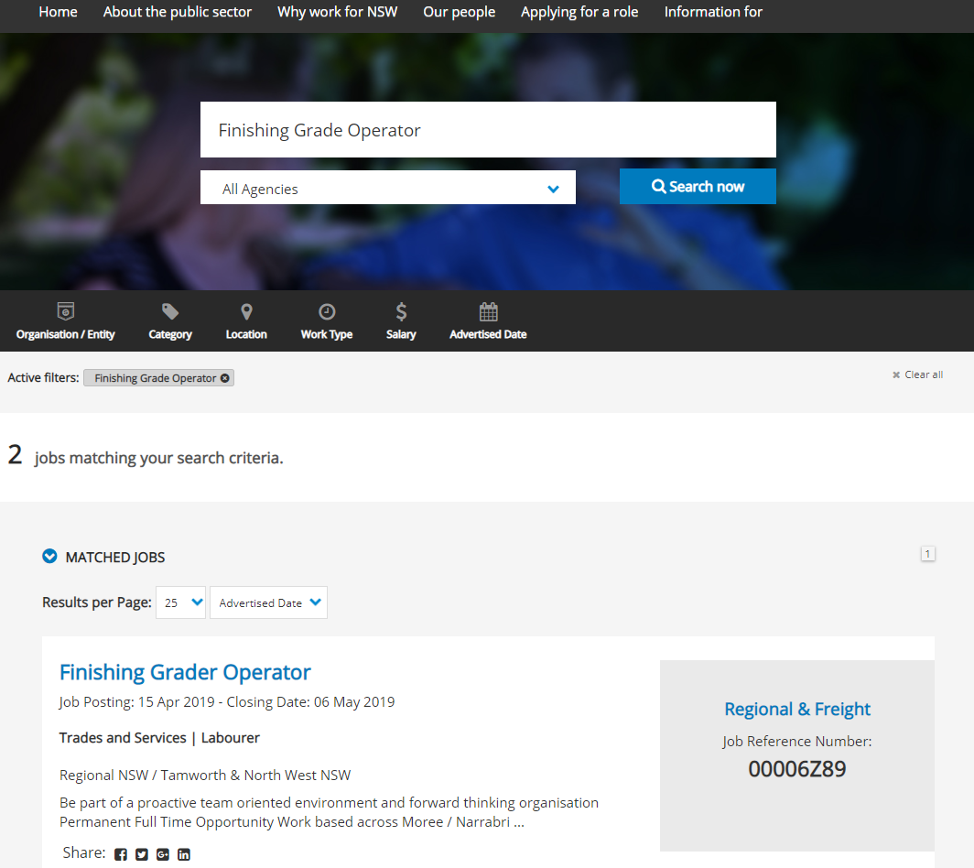
Step 2
Step 1
Step 3: To apply, click the ‘Apply Online’ button at the bottom of the advertisement (ensure that your application is submitted by the closing date):
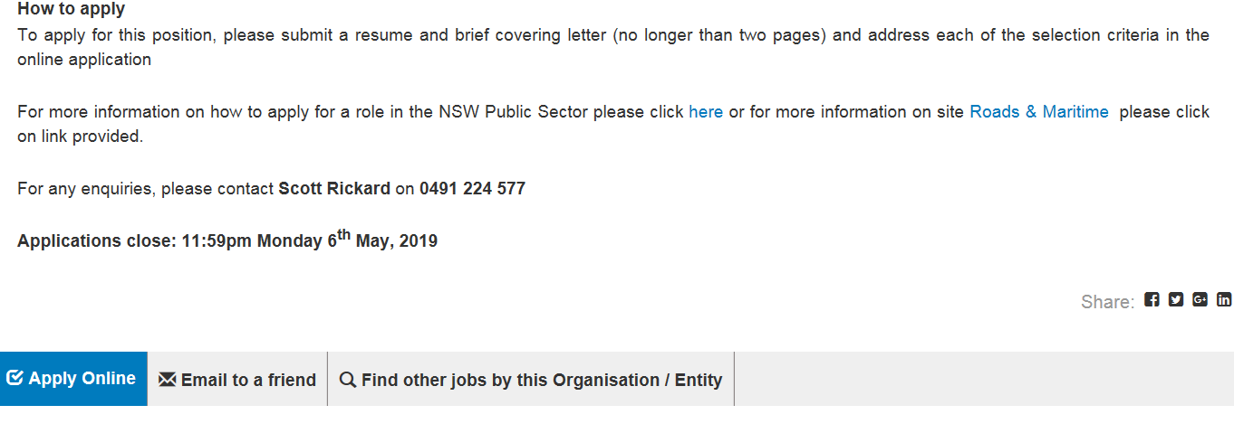
Step 3
Step 4: If you have an existing account, log in by entering your email address and password. If you have forgotten your username or password, click the links highlighted below and follow the prompts to reset.
If you are a New User, click on the link highlighted below and follow the prompts to create a new account.
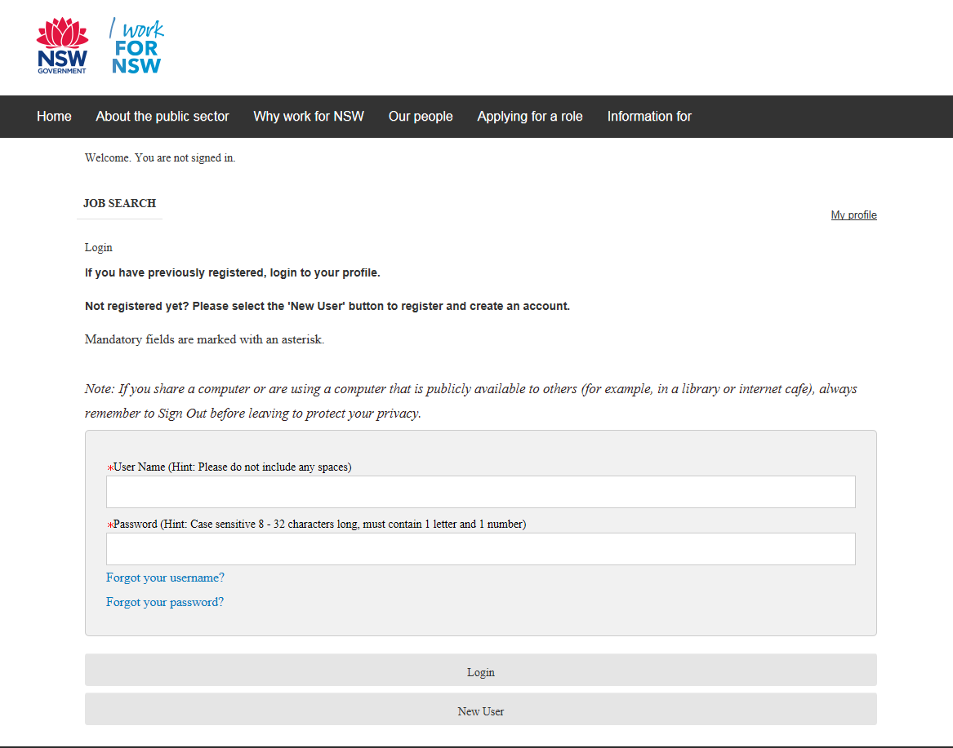

Step 4

You will then be directed to a nine-step process to begin submission of your application. Any field that is marked as a red asterisk is a mandatory field.
PLEASE NOTE: You will be able to save as draft the progress of your application at any stage of the nine steps and come back to it later.
Step 5: Personal details. Fill in your personal details on page 1. Once you complete all fields, click save and continue at the bottom of the page to proceed.
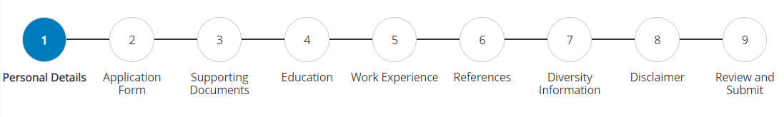
Step 6: Application form. Fill in your application form on page 2. Once you complete all fields, click save and continue at the bottom of the page to proceed.
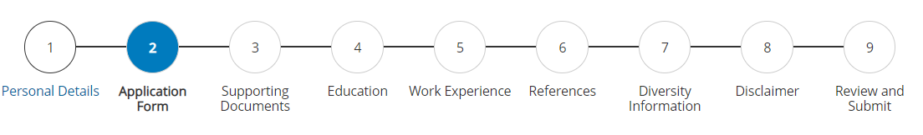
Step 7: Supporting documents. You can choose to either upload your resume and other supporting documents such as a cover letter as an attachment or you may choose to build your resume and cover letter in the application process itself. We would recommend uploading your resume and supporting documents if any as an attachment as it is easier for the hiring manager to read. If you choose to upload your relevant attachments (CV/Resume and Cover Letter) click on choose file, select the relevant file from your computer drive and click attach.
Type in or copy and paste the contents of your cover letter in the cover letter section as highlighted below, addressing the relevant job criteria. Click save and continue at the bottom of the page to proceed.
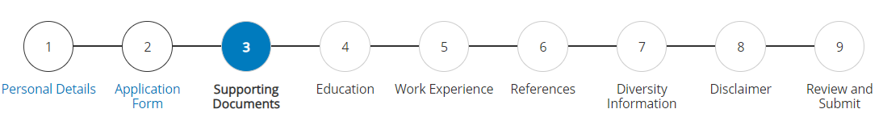

Step 8: Education. If you’ve attached a resume as one of your supporting documents which outlines your education then leave the education fields blank as these fields aren’t mandatory. Click save and continue.
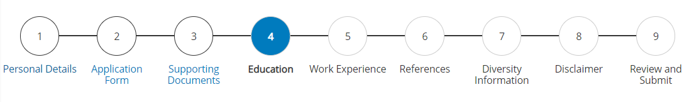
Step 9: Work experience. If you’ve attached a resume document to your application which outlines your work experience leave the work experience fields blank as these fields aren’t mandatory. Click save and continue.
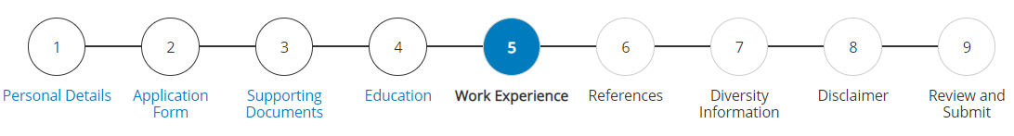
Step 10: References. We would recommend you fill in the contact details of your 2 referees who will act as your references. Ideally your referees would be 2 recent managers that have recently supervised you. To add additional referee details click add reference as highlighted below.
We won’t contact your referees until we have your permission to do so. Please note these fields are not mandatory. Click save and continue.
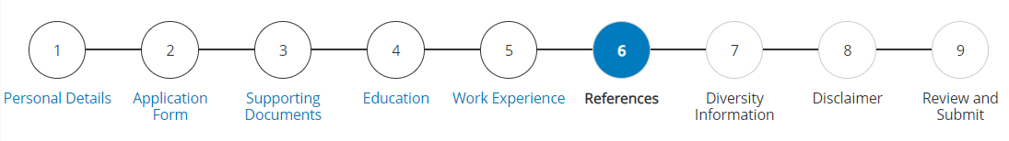
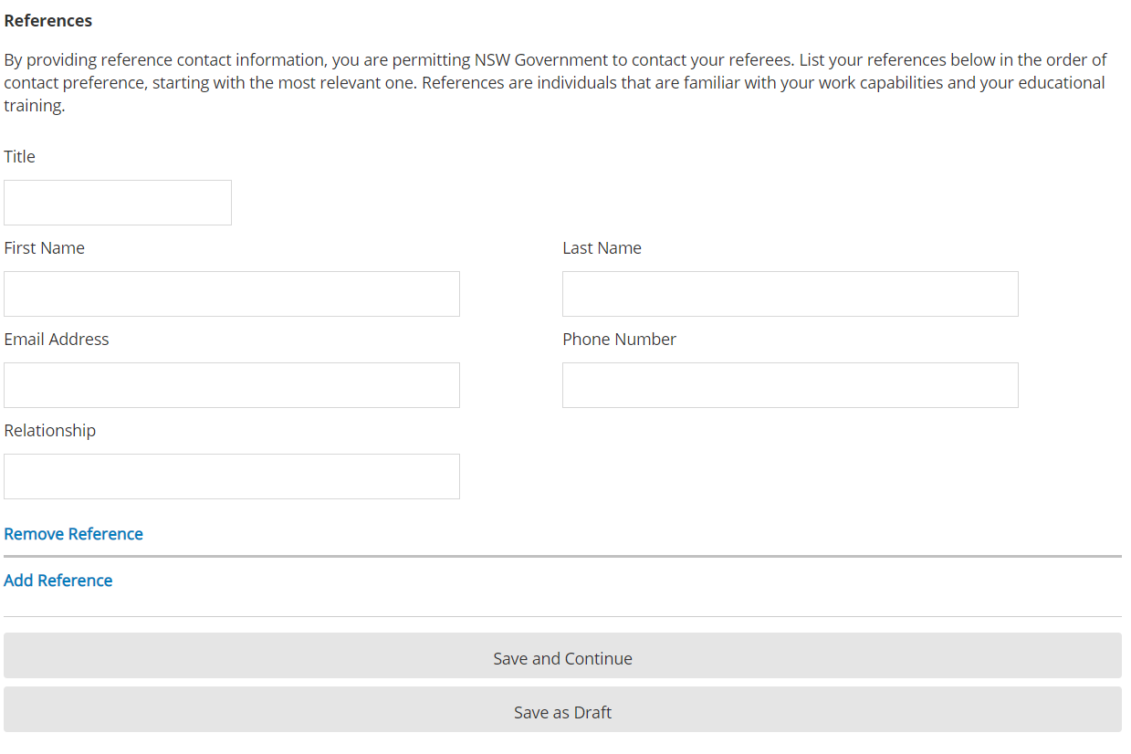
Page 7: Diversity Information. On this page you will be asked a series of questions related to your background and diversity. Please note these fields are already pre-populated, therefore you’ll need to select an appropriate answer from the drop-down menu as highlighted below. The information you provide will assist our organisation from a reporting perspective only and will not be used for any other purposes. Click save and continue to proceed.

Page 8: Disclaimer. This section outlines the Terms and Conditions including our privacy statements in relation to your personal information. If you accept these terms, you will need to type your full name and email address into the boxes located under the statements as highlighted below.
Typing your full name and email address will be considered your electronic signature, accepting the terms and conditions.
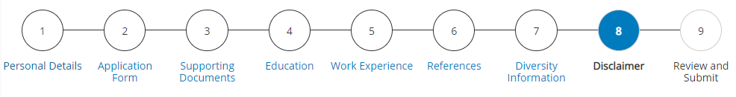
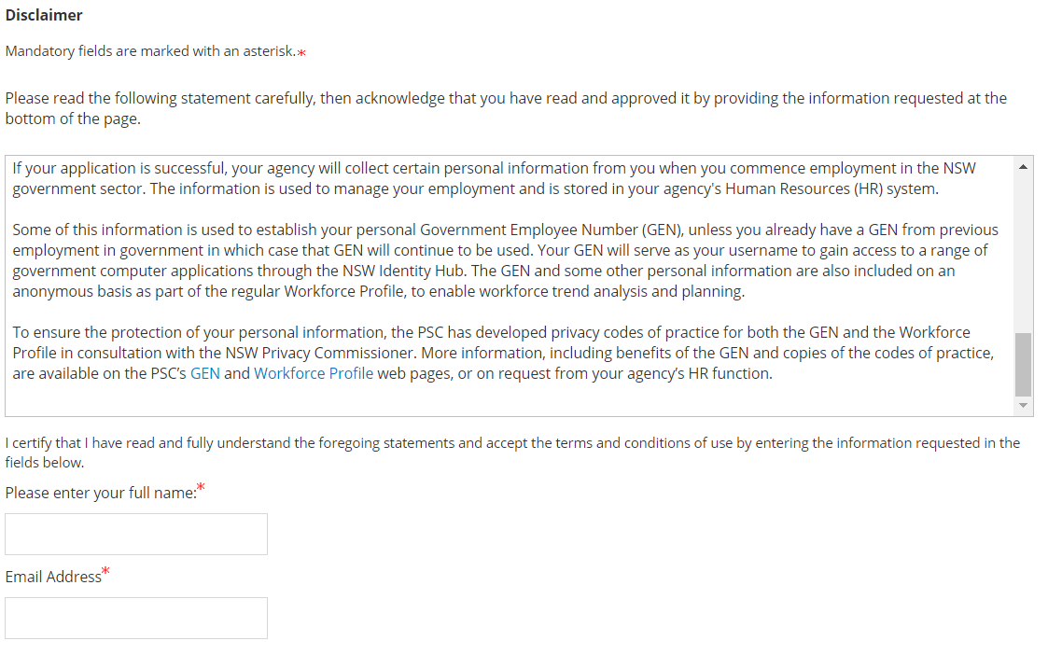
Page 9: Review and Submit. This page provides a summary of the eight previous stages. You are able to review the information you have provided throughout your application and make amendments by clicking edit to the right of each of the headings. If you are happy with all of the information and attachments provided, you may click submit at the bottom of the page.
If you wish to save the application and finish it later, you may click save as draft and log in at a later time to resume your application.
